“ONLINE SHOPPING ”

SYED MEHMOOD UL HASSAN GILLANI SE_18099
TANVEER AHMED SE-18103
HJANZAIB RASHEED SE-18095

INDEX

Sr no. | Topics | Page no.
1. | Introduction
2 | Objective
3 | Requirement Analysis
4 | Hardware & Software requirement
5 | A Word about PHP
6 | SDLC
7 | System analysis

8 | Feasibility study
9 | System design
10 | E – R diagram
11 | Data flow diagram
12 | Project layout
13 | Database
14 | Benefits
15 | Coding

16 | TESTING
17 | IMPLEMENTATION
18 | FUTURISTIC SCOPE
19 | BIBLIOGRAPHY
20 | CONCLUSION

INTRODUCTION

Shopping Cart
- Project Features
- Software Requirement
- Installation Steps
- Download Project

Shopping Cart System
Use of Shopping Cart system
Shopping Cart System is the Simple shopping Solution. It's a full-featured website and shopping cart system that bends over backwards to give you the flexibility you need to run your online store. The basic concept of the application is to allow the customer to shop virtually using the Internet and allow customers to buy the items and articles of their desire from the store. The information pertaining to the products are stores on an RDBMS at the server side (store). The Server process the customers and the items are shipped to the address submitted by them. The details of the items are brought forward from the database for the customer view based on the selection through the menu and the database of all the products are updated at the end of each transaction.
What is Shopping Cart system?
Online shopping is a form of electronic shopping store where the buyer is directly online to the seller's computer usually via the internet. There is no intermediary service. The sale and purchase transaction is completed electronically and interactively in real-time. The development of this new system contains the following activities, which try to develop on-line application by keeping the entire process in the view of database integration approach. User gets its eamil id and password to acces their account.
Administrator of Shopping Cart System has multiple features such as Add, Delete, Update shopping Items.
Features of shopping cart system.
- Secure registration and profile management facilities for Customers.
- Browsing through the e-Mall to see the items that are there in each category of products like Apparel, Kitchen accessories, Bath accessories, Food items etc.
- Creating a Shopping cart so that customer can Shop N number of items and checkout finally with the entire shopping cart
- Customers should be able to mail the Shop about the items they would like to see in the Shop
- Secured mechanism for checking out from the Shop( Credit card verification mechanism ).Updates to customers about the Recent Items in the Shop.
- Uploading Most Purchased Items in each category of products in the Shop like Apparel, Kitchen accessories, Bath accessories, Food items etc.
Brief overview of the technology:
Front end: HTML, CSS, JavaScript
- HTML: HTML is used to create and save web document. E.g. Notepad/Notepad++
- CSS : (Cascading Style Sheets) Create attractive Layout
- JavaScript: it is a programming language, commonly use with web browsers.
Back end: PHP, MySQL
- PHP: Hypertext Preprocessor (PHP) is a technology that allows software developers to create dynamically generated web pages, in HTML, XML, or other document types, as per client request. PHP is open source software.
- MySQL: MySql is a database, widely used for accessing querying, updating, and managing data in databases.
Software Requirement(any one):
- WAMP Server
- XAMPP Server
- MAMP Server
- LAMP Server
Installation Steps:
- Download zip file and Unzip file on your local server.
- Put this file inside â€œc:/wamp/www/â€ .
- Database Configuration:
Open phpmyadmin
Create Database named shop.
Import database shop.sql.
- Open Your browser put inside URL: http://localhost/online_shopping/
- To Login as admin putinside URL: http://localhost/online_shopping/admin/
Admin login details: Login Id: admin
Password: priya123

OBJECTIVE

Starting the project, we should fully know about the meaning of project. There are seven letters in the word “PROJECT”. Each character has its own technical meaning.
P – planning : this deals with the idea at thinking and which are required for project.
R – Resource : the money problem will be solved and resources from which collected.
O – Operating : the procedure from which getting job is prepared in a systematic way is known as operation.
J – Joint effort : this is directly proper to a operation output is a made of several person working sincerely is known as JOIN EFFORT.
E – Engineering : A well educated engineer can do this work in a better way to find out better result. Hence the project is as engineer function.
C – Cooperation : To make the project successfully, it is necessary for its success and completion of project.
T – Technique : It must as it gives a better shape. It is not possible to complete the project without technique.

The project is a system that gives the systematic way of planning and working.
Or
It representing the temporary task, in a scientific manner carried out of engineers to achieve a goal.
REQUIREMENT ANALYSIS

A Subject People are Interested In
The most successful blogs are written about topics that have a broad appeal. The more people who are interested in the topic you write about at your blog, the more people will search for information on that topic and want to read about it.

Passion for Your Subject
As a blogger, you have to write about your blog's subject a lot. The writing is nonstop. If you don't love your blog's topic, it will show. Readers can detect when a blogger is just going through the motions rather than speaking from the heart.

Commitment
Successful blogging requires a massive amount of sweat equity and dedication. Building a successful blog requires more than just publishing a new post a few times a week. The most successful blogs are updated frequently (often several times each day), and the bloggers behind those blogs work relentlessly to promote their blogs and drive traffic to them.

Time
Building a successful blog requires a massive time investment. Growing a blog doesn't stop with publishing post. Top bloggers spend a lot of time everyday promoting their blogs, researching and reading to drive traffic to it.

A Desire to Network
Socializing is a critical component of developing a successful blog. Blogging by nature is a social medium, and successful blogs become so primarily because of the strong sense of community surrounding them. Top bloggers take time to respond to comments and interact with their blogs' readers as well as network on social sites, forums and more all in an effort to further promote their blogs.

A Desire to Keep Learning
The blogosphere is ever-changing, which means top bloggers are always looking for new ways to enhance their blogs by persistently researching anything and everything related to blogging.

A Love of Research and Reading
Successful bloggers read a lot in order to stay updated on their blogs' topics and the blogosphere as a whole.

Creativity
A successful blog is typically updated very frequently. That means successful blogs always provide fresh, unique content to their readers. Writing that new content requires a great deal of creativity to keep readers from feeling bored or from feeling like the blog does not bring them any value.

Patience
Blogging success does not happen overnight. Be prepared to stay dedicated to promoting your blog for the long haul. Eventually, your hard work should pay off with increased traffic and a significant growth in popularity of your blog. The key is to not give up.

HARDWARE & SOFTWARE REQUIREMENT

Hardware requirement of project are :

Section | Requirements and Recommendations
Supported Operating Systems | Microsoft Windows 7 32/64 bit  Microsoft Windows 8 32/64 bit
Additional Software Requirements | Adobe Acrobat Reader 4.0 or higher
Display | Minimum resolution 800 x 600 pixel  1024 x 768 pixel recommended
RAM | 2 GB or more  4 GB or more recommended especially for Microsoft Windows Vista, 7 and 8
CPU | 1.5 GHz processor speed or higher

Software requirement of project are :

Section | Requirements and Recommendations
Supported Operating Systems | Microsoft Windows XP  Microsoft Windows Vista  Microsoft Windows 7 32/64 bit
Additional Software Requirements | .NET Framework 1.1 and SP 1 for .Net FrameWork 1.1

A WORD ABOUT PHP

What is PHP?
PHP (Hypertext Preprocessor) is a widely-used open source general-purpose scripting language that is especially suited for web development and can be embedded into HTML.
The best things in using PHP are that it is extremely simple for a newcomer, but offers many advanced features for a professional programmer. Don't be afraid reading the long list of PHP's features. You can jump in, in a short time, and start writing simple scripts in a few hours.
PHP is an acronym for "PHP: Hypertext Preprocessor". PHP is a widely-used, open source scripting language. PHP scripts are executed on the server. PHP is free to download and use
PHP is an amazing and popular language!
It is powerful enough to be at the core of the biggest blogging system on the web (Word Press)!
It is deep enough to run the largest social network (Facebook)
It is also easy enough to be a beginner's first server side language
What is a PHP File?
PHP files can contain text, HTML, CSS, JavaScript, and PHP code. PHP code are executed on the server, and the result is returned to the browser as plain HTML. PHP files have extension ".php"

What Can PHP Do?
PHP can generate dynamic page content. PHP can create, open, read, write, delete, and close files on the server. PHP can collect form data. PHP can send and receive cookies. PHP can add, delete, modify data in your database. PHP can be used to control user-access. PHP can encrypt data.
With PHP you are not limited to output HTML. You can output images, PDF files, and even flash movies. You can also output any text, such as XHTML and XML.
Why PHP?
PHP runs on various platforms (Windows, Linux, Unix, Mac OS X, etc.) PHP is compatible with almost all servers used today (Apache, IIS, etc.) PHP supports a wide range of databases. PHP is free. Download it from the official PHP resource: www.php.net. PHP is easy to learn and runs efficiently on the server side

How Can We Set Up PHP on Your Own PC :
However, if your server does not support PHP, you must:
Install a web server
Install PHP
Install a database, such as MySQL
The official PHP website (PHP.net) has installation instructions for PHP: http://php.net/manual/en/install.php

SDLC

SOFTWARE DEVELOPMENT LIFE CYCLE

The software development life cycle (SDLC) is a framework defining tasks performed at each step in the software development process. SDLC is a structure followed by a development team within the software organization. It consists of a detailed plan describing how to develop, maintain and replace specific software. The life cycle defines a methodology for improving the quality of software and the overall development process.
This term is also known as the software development process.

SDLC consists of following activities:
Planning:
The most important parts of software development, requirement gathering or requirement analysis are usually done by the most skilled and experienced software engineers in the organization. After the requirements are gathered from the client, a scope document is created in which the scope of the project is determined and documented.
Implementation:

The software engineers start writing the code according to the client's requirements.
Testing:
This is the process of finding defects or bugs in the created software.
Documentation:
Every step in the project is documented for future reference and for the improvement of the software in the development process. The design documentation may include writing the application programming interface (API).

Deployment and maintenance:

The software is deployed after it has been approved for release.

Maintaining:

Software maintenance is done for future reference. Software improvement and new requirements (change requests) can take longer than the time needed to create the initial development of the software.

There are several software development models followed by various organizations:
Waterfall Model:
This model involves finishing the first phase completely before commencing the next one. When each phase is completed successfully, it is reviewed to see if the project is on track and whether it is feasible to continue.
V-Shaped Model:
This model focuses on execution of processes in a sequential manner, similar to the waterfall model but with more importance placed on testing. Testing procedures are written even before the commencement of writing code. A system plan is generated before starting the development phase.
Incremental Model:

This life cycle model involves multiple development cycles. The cycles are divided up into smaller iterations. These iterations can be easily managed and go through a set of phases including requirements, design, implementation and testing. A working version of the software is produced during the first iteration, so working software is created early in the development process.
SYSTEM ANALYSIS

System analysis is the process of examining a business situation for the purpose of developing a system solution to a problem or devising improvements to such a situation. Before the development of any system can begin, a project proposal is prepared by the users of the potential system and/or by systems analysts and submitted to an appropriate managerial structure within the organization.

Assuming that a new system is to be developed, the next phase is a system analysis. Analysis involved a detailed study of the current system, leading to specifications of a new system. Analysis is a detailed study of various operations performed by a system and their relationship with in and outside the system. During analysis, data are collected on the available files, decision points and transactions handled by the present system. Interviews, on-site observation and questionnaire are the tools used for system analysis. Using the following step it becomes easy to draw the exact boundary of the new system under consideration :

Keeping in view the problems and new requirements workout the pros and cons including new areas of the system.

All procedures, requirement must be analysed and documented in the form of detailed data flow diagrams, data dictionary, logical data structures and miniature specifications. System analysis also includes sub-dividing of complex process involving the entire system, identifiers of data stores and manual processes.

The main points to be discussed in system analysis are :
Specification of what the new system is to accomplish based on the user requirements.

Functional hierarchy showing the function to be performed by the new system and their relationship with each other.
Function network which are similar to function hierarchy but they highlight the those functions which are common to more than one procedure.

FEASIBILITY STUDY
The feasibility study investigates the problem and the information needs of the stakeholders. It seeks to determine the resources required to provide an information systems solution, the cost and benefits of such a solution, and the feasibility of such a solution. The analyst conducting the study gathers information using a variety of methods, the most popular of which are:
- Interviewing users, employees, managers, and customers.
- Developing and administering questionnaires to interested stakeholders, such as potential users of the information system.
- Observing or monitoring users of the current system to determine their needs as well as their satisfaction and dissatisfaction with the current system.
- Collecting, examining, and analyzing documents, reports, layouts, procedures, manuals, and any other documentation relating to the operations of the current system.
- Modeling, observing, and simulating the work activities of the current system.
The goal of the feasibility study is to consider alternative information systems solutions, evaluate their feasibility, and propose the alternative most suitable to the organization. The feasibility of a proposed solution is evaluated in terms of its components. These components are:

Economic feasibility :
The economic viability of the proposed system. The proposed project's cost and benefits are evaluated. Tangible costs include fixed and variable costs, while tangible benefits include cost savings, increased revenue, and increased profit. A project is approved only if it covers its cost in a given period of time. However, a project may be approved only on its intangible benefits such as those relating to government regulations, the image of the organization, or similar considerations.

Technical feasibility :
The possibility that the organization has or can procure the necessary resources. This is demonstrated if the needed hardware and software are available in the marketplace or can be developed by the time of implementation.

Operational feasibility:
The ability, desire, and willingness of the stakeholders to use, support, and operate the proposed computer information system. The stakeholders include management, employees, customers, and suppliers. The stakeholders are interested in systems that are easy to operate, make few, if any, errors, produce the desired information, and fall within the objectives of the organization.

SYSTEM DESIGN

What is systems design?

Systems design is simply the design of systems. It implies a systematic and rigorous approach to design—an approach demanded by the scale and complexity of many systems problems.

Where did it come from?

Systems design first appeared shortly before World War II as engineers grappled with complex communications and control problems. They formalized their work in the new disciplines of information theory, operations research, and cybernetics. In the 1960s, members of the design methods movement (especially Horst Rittel and others at Ulm and Berkeley) transferred this knowledge to the design world. Systems design continues to flourish at schools interested in design planning and within the world of computer science. Among its most important legacies is a research field known as design rationale, which concerns systems for making and documenting design decisions.

What can designers learn from systems design?

Today, ideas from design methods and systems design may be more relevant to designers than ever before—as more and more designers collaborate on designing software and complex information spaces. Frameworks suggested by systems design are especially useful in modeling interaction and conversation. They are also useful in modeling the design process itself.

What is the most important thing to be aware of in systems design?

A systems approach to design asks:
For this situation, what is the system?
What is the environment?
What goal does the system have in relation to its environment?
What is the feedback loop by which the system corrects its actions?
How does the system measure whether it has achieved its goal?
Who defines the system, environment, goal, etc.—and monitors it?
What resources does the system have for maintaining the relationship it desires?
Are its resources sufficient to meet its purpose?

Is systems design incompatible with user-centered design?

A systems approach to design is entirely compatible with a user-centered approach. Indeed, the core of both approaches is understanding user goals. A systems approach looks at users in relation to a context and in terms of their interaction with devices, with each other, and with themselves.

What is the relationship between systems design and cybernetics?

Cybernetics (the science of feedback) provides an approach to systems and a set of frameworks and tools. Among the most important ideas for designers:
Definition of a system depends on point of view.
We are responsible for our actions.
All interaction is a form of conversation
All conversation involves goals, understandings, and agreement.

Are there times when systems design isn’t appropriate?

A systems approach to design is most appropriate for projects involving large systems or systems of systems. Such projects typically involve many people, from many disciplines, working together over an extended period of time. They need tools to cope with their project’s complexity: to define goals, facilitate communications, and manage processes. Solo designers working on small projects may find the same tools a bit cumbersome for their needs.

E – R DIAGRAM

Entity Relationship Diagrams are a major data modeling tool and will help organize the data in your project into entities and define the relationships between the entities. This process has proved to enable the analyst to produce a good database structure so that the data can be stored and retrieved in a most efficient manner.

Entity
A data entity is anything real or abstract about which we want to store data. Entity types fall into five classes: roles, events, locations, tangible things or concepts. E.g. employee, payment, campus, book. Specific examples of an entity are called instances. E.g. the employee John Jones, Mary Smith's payment, etc.

Relationship
A data relationship is a natural association that exists between one or more entities. E.g. Employees process payments. .
Attribute
A data attribute is a characteristic common to all or most instances of a particular entity. Synonyms include property, data element, field. E.g. Name, address, Employee Number, pay rate are all attributes of the entity employee. An attribute or combination of attributes that uniquely identifies one and only one instance of an entity is called a primary key or identifier. E.g. Employee Number is a primary key for Employee.
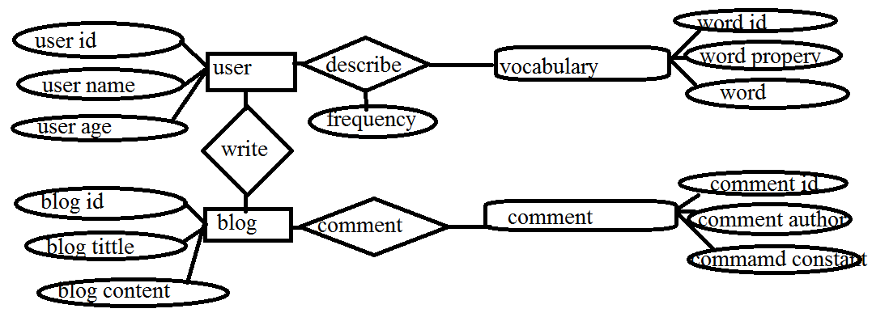
DATA FLOW DIAGRAM

A Data Flow Diagram (DFD) is a graphical representation of the "flow" of data through an information system. A DFD is often used as a preliminary step to create an overview of the system. DFDs can also be used for the visualization of data processing (structured design).
A DFD shows what kind of information will be input to and output from the system, where the data will come from and go to, and where the data will be stored. It does not show information about the timing of process or information about whether processes will operate in sequence or in parallel.
History
Data flow diagrams were proposed by Larry Constantine. The original developer of structured design, based on Martin and Estrin's "Data Flow Graph" model of computation. Starting in the 1970s, data flow diagrams (DFD) became a popular way to visualize the major steps and data involved in software system processes. DFDs were usually used to show data flows in a computer system, although they could in theory be applied to business process modeling. DFD were useful to document the major data flows or to explore a new high-level design in terms of data flow.
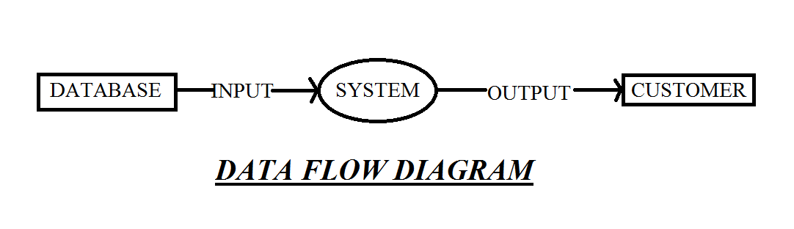

Data flow diagram Symbols:
External entities: rectangular box
Data flow: arrow headed lines
Process/ function: bubble/ circle.
Data store: narrow opened rectangle.
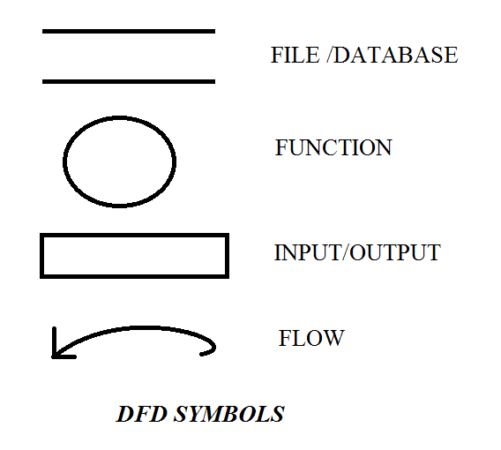

A data flow diagram represents the following:
External devices sending or receiving data.
Processes that change the data.
Data flow themselves.
data storage locations.

Types of data flow diagram :
There are two types of data flow diagrams, namely physical data flow diagrams and logical data flow diagram and it is important to difference between the two:
Physical data flow diagram:
An implementation dependent view of the current system, showing what tasks are carried out and how they are performed. Physical characteristic can include:
Names of people.
Form and document name and number.
Name of departments.
Master and transaction files.
Equipment and device used.
Locations.
Names of procedures.

Logical data flow diagram :
An implementation independent view of the system, focusing on the flow of data between processes without regard for the specific devices, storage location or people in the system. The physical characterstics listed above for physical data flow diagram will not be specified.

PROJECT LAYOUT

PROJECT PLAN:
The Project Plan (sometimes called project initiation document or project scoping report) is produced by the Project Manager following a brief Scoping Project Study. It should establish:
What the project is to achieve
A detailed time schedule for carrying out the project
Details of the resources required - people, money, sections
Who is to be involved in the project
What the risks and implementation issues are.
A typical format is given below. As you may notice, the first five items (Part A) focus on what the project is to achieve whilst the last four items (Part B) go into more depth about how the project should be carried out.

Project Plan

Part A
1. Title of project,
2. Background to the Project
3. Terms of Reference & Key Objectives
4. Benefits & Costs Analysis
5. Risk Assessment

Part B
6. Resources likely to be needed
7. Costs
8. Proposed Project Organisation
9. Time Schedule

Project Plan

Part A

1. Title of project,
Together with the names of the Project Manager and Project Sponsor.

2. Background to the Project
A brief description of the background to the project including how the project came about, what the project is about, why we are undertaking the project, and what in very broad terms the outcome of the project will be to the organization.

3. Terms of Reference & Key Objectives
First, a brief overall definition and description of the project and its aims including some reference to likely timescales, budget and resources, and what the project will aim to deliver. Then a statement of what the project is to deliver - the key objectives. The latter is often done as a listing the main stakeholders of the project with a statement for each of what the project will aim to deliver to them.

4. Benefits & Costs Analysis
A brief statement of the main benefits to be gained from undertaking this project and the main costs which will be incurred and which need to be controlled and contained. Not necessarily a full cost-benefit analysis but a brief overview.

5. Risk Assessment
The main risks - implementation issues which may delay the project. The priority items should be identified with suggestions as to how they could be averted or their impact lessened.
One of the simplest and best ways of doing this is to create a ‘risk register’ identifying all the events that could cause problems for the project, and then mapping these onto a Hi-Lo diagram.

Part B

6. Resources likely to be needed
The resources, money and peoples time, which the project manager will need to carry out this project.

7. Costs
A good estimate of overall costs to be incurred and the required budget.

8. Proposed Project Organization
A description of the overall project organisation, in particular the project manager, project sponsor (individual or group), team members if any, key contributors (IT, stats, etc).
Also, if the project warrants project review meetings, when they should take place and who should be involved.

9. Time Schedule
A time plan showing the key activities which need to take place and estimates of when the activity needs to be carried out, with key milestone dates.
Best done with one of the planning techniques - Gantt Charts, Milestone Plans, Stages Diagram, or even Critical Path Analysis if the project warrants it.
DATA BASE

SQL REPORT
Host: localhost
Database: blog
Generation Time: Apr 15, 2015 at 10:07 AM
Generated by: phpMyAdmin 3.3.2deb1ubuntu1 / MySQL 5.1.73-0ubuntu0.10.04.1
SQL query: SELECT * FROM `blog_comments` LIMIT 30, 30 ;
Rows: 22
comment_id | post_id | name | comment | comment_time
31 | 10 | Asd | aaaaaaaaaaaaaaaaaaaaa | 2012-06-07 19:48:17
32 | 12 | Channi | comments | 2012-06-08 08:46:41
38 | 18 | asdfdsaf | A | 2012-06-09 18:52:19
45 | 23 | Channi | asdfsf asdfsf asdfsf asdfsf asdfsf asdfsf asdfsf a... | 2012-06-09 20:14:26
46 | 26 | Poink | here's a comment by poink | 2012-06-10 12:27:37
47 | 35 | Some User | Wow...what an article....(js kidding..u suck!!) | 2012-06-10 19:18:00
48 | 35 | Some User | s coming week, have fun doing this exercise Becaus... | 2012-06-10 19:18:12
49 | 35 | Some User | Then she does a rough sketch in pencil on the canv... | 2012-06-10 19:18:21
50 | 26 | Some User | major scientific breakthroughs come after years an... | 2012-06-10 19:18:33
51 | 26 | Some User | f funny to keep watching people who want things to... | 2012-06-10 19:18:41
52 | 34 | Some User | Knowing what your dream is the beginning of living... | 2012-06-10 19:21:28
53 | 34 | Some User | May your life be filled with love, happiness and i... | 2012-06-10 19:21:38
54 | 33 | Some User | Sublime Text 2 is currently available for all majo... | 2012-06-10 19:21:52
55 | 33 | Some User | Sublime is in active development. | 2012-06-10 19:22:14
56 | 32 | Some User | About the Author: I am a biotechnologist from Indi... | 2012-06-10 19:22:32
57 | 32 | Some User | It has also been observed by many throughout the c... | 2012-06-10 19:22:44
58 | 32 | Some User | Be brave and live a courageous life! | 2012-06-10 19:22:51
59 | 32 | Some User | I have received a lot from this world through many... | 2012-06-10 19:23:06
61 | 31 | Some User | If the world would look at each one of us and ask ... | 2012-06-10 19:23:45
62 | 31 | Some User | If only we will recognize the importance of failur... | 2012-06-10 19:23:55
63 | 31 | Some User | I have received a lot from this world through many... | 2012-06-10 19:24:09
64 | 39 | Vinni | Nbotug | 2015-03-20 13:36:23

BENEFITS

20 years ago, blogs didn’t exist. Today, there are over 150 million of them.
Still, I get a lot of puzzled looks when I tell people that having a blog is the single most important thing a business, cause, or person can do to advance online. Even though ‘blogging’ has hit it big, most people don’t get what makes blogging so powerful, helpful, and beneficial.
To put an end to that, I’ve compile a list of the 20 biggest benefits of having a blog below. If you’re among the uninitiated, prepare to be enlightened. If you’ve already started a blog of your own then you can consider this an affirmation of why you do what you — and a good place to direct people who still think that a blog is just a pointless public diary.

The 20 Biggest Benefits of Blogging Are Given Below:

1 Get a Better Job.

2 Start a New Business.

3 Get More Clients to Your Existing Business.

4 Become a Better Writer.

5 Become a Published Author.

6 Get Immediate Feedback.

7 Learn More About a Group of People.

8 Gain Influence.

9 Establish Yourself as an Expert in Your Field.

10 Build a Network.

11 Learn In-Demand Skills.

12 Improve Your SEO.

13 Collect Emails.

14 Stay Knowledgeable in Your Field.

15 Sell a Product.

16 Talk to Your Idols.

17 Express Yourself.

18 Help Others.

19 Build Trust Online.

20 Take Control of Your Online Identity.

